Roll no ; 159
Syeda Ayma Rubab
Assignmemt:-
“School Organization amd
management”
Topic:-
School as an open system System
system is the collection of detailed methods, procedures, and routines that are used to complete a specific task, perform a duty, or solve a problem.

Typea:-
There are two types of systems:
• open systems • closed systems. Open system ;-
An open system interacts with the environment as if it were a component of the operating system.
As an example of an open system, consider a publicly traded corporation. Open education is being hailed as a gamechanger in education.

Closed System:-
A closed system does not. According to open-systems views, schools are constantly interacting with their surroundings. According to a closedsystem theory, schools are capable of self-managing the majority of their problems. Students are interacting with teachers in order for them to become aware of the social responsibilities of society as part of the learning process.

School system:-
The school system becomes a part of the total social structure, it is recognized as a separate institution by its members. According to the views of open school systems, schools constantly interact with one another. Systems is used within and outside an organization to explain and predict how a decision will affect the organization.

School as an open system;-
The open system is a way of thinking about the relationship between the school and its environment. It is based on the idea that the school is a system that is open to influence from its environment, and that the environment can have a significant impact on the functioning of the school.
Open system Education’s primary goal is to provide a threefold educational experience that combines knowledge-sharing, research, and communication.

The open system has been used to explain a number of phenomena in education, including the impact of the community on the schools, the impact of the schools on the community, and the relationship between the school and the larger society. It has also been used to examine the way that the educational system is organized and the way that it operates.

open system students participate in a variety of activities in the school, and decision-making structures must be well-organized in a variety of contexts. These systems are highly dependent on each other and are extremely interactive in nature.
Teaching and learning improve
Learning and teaching can be improved by exchanging ideas between open schools and other schools. Teachers and students interact during the learning process in order for students to become educated citizens.

• A school is an open social system that consists of various parts 1. Internal environment
2. External environment

Components;-
- Input
- Transformation process
- Output
- Feedback
- Environmemt
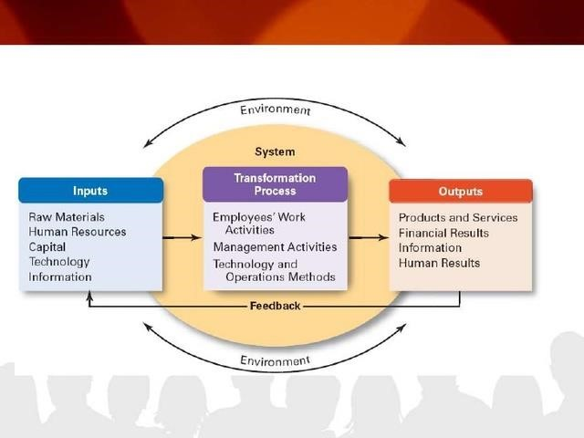

Inputs;-
System such as schools use four kinds of inputs or resources from the environmemt. Human resources, financial resources , physical resouces and informational resources. “Human resources” use Administrative, Staff talent , labor.
“Financial resouces” are the capital the school district uses to finance both ongoing and long – term operations .
“Physical resouces” includes
Supplies , materials, facilities, curricula , data and other kinds of information utilized by the school district.

Transformation process:₋
The school administration job involve combining and coordinating these various resources to attain the school’s goals – learning for all. The interaction between students and teacher in part of transformation or learning process by which students become educated citizen capable of contributing to society.
This transformation process includes the internal operation of the organization and its sysyem of operational management. Some components of the system of operational management include the technical competence of school administration and other staff, their plans of operation and their ability to cope the change.

Outputs:₋
It is the external variables. In social sysymtem outputs are thd attainment of goals or objectives of the school and represent by the products, results, outcomes,or accomplishments of the system .Although the kinds of outputs will vary with a specific school, with a specifi school, they usually include the one or more of the following growth and achievement level of the students and teachers, students dropout rates , school community relation.

Feed back;-
Feedback is the crucial to the success of the school operation. Negative feedback for E.g can be used to correct defficiences in the transformation process or the inputs or both, which in turn will have an effect on the school’s future outputs.

Environment;-

The environment surrounding the school/school district includes the social, political, and economic forces that impinge on the organization. The environment in the open systems model takes on added significance today in a climate of policy accountability. The social, political, and economic contexts in which school administrators work are marked by pressures at the local, state, and federal levels. Thus, school administrators today find it necessary to manage and develop internal operations while concurrently monitoring the environment and anticipating and responding to external demands.
“Public School” system was underperforming. With recognition of an achievement gap and the rise of international educational comparisons, states began to focus their policy on standards, accountability, and the improvement of student academic achievement
“Local school” administrators also face a number of challenges that are exclusively local in nature, such as bond referenda, difficult school boards, and teacher unions.
As an example of an open system, consider a publicly traded corporation. Open education is being hailed as a gamechanger in education

Benefits:-
Students’ easily access to learning materials and methods. The term open textbooks refers to books that are freely available online and can be used by students in any format or device.
Open data, in addition to being an example of open learning, can also be found. A data set that is freely available for anyone to use, reuse, and distribute, subject to a minimum requirement that it be attribute and shared. Open data can be found in a variety of formats, including Excel files, JSON files, and XML files.

Conclusion:-
open systems are dynamic and adaptive, they can transform their inputs to produce new outputs. Open systems are made up of the ability to change and grow in large part due to their adaptability.
To ensure stability and success, the school ensures that it can continue to serve its students and community in the best possible way. Because open systems have the ability to adapt to changes in their environment in a matter of seconds, they are extremely important to innovation and growth.

Name: Ayesha jameel bajwa
Roll no: 127
Topic: School as a open system

System:
A system is a way of working, organizing, or doing something which follows a fixed plan or set of rules. You can use system to refer to an organization or institution that is organized in this way.

Open system and a closed system
- An open system allows the influx and out-flux of energies, materials, and information. Closed systems do not allow either the influx or out-flux of materials.
The school is considered an open system since it is directly linked with the community. The school interacts with the community through various activities, and decision making structures should be well organized in an open context. All these systems are mutually dependent on each other and are highly interactive.
School as a hub that's connected to various elements. It gets inputs like students, staff, curriculum, and funding. The school processes these inputs – through teaching and administration – and then outputs educated students, research, and community services. Feedback from the outputs can lead to improvements or changes within the school. It's a continuous cycle of input, process, output, and feedback that keeps the school evolving
An open system in the context of a school means it is dynamic and responsive. Here's a bit more detail:
1.Interaction with Environment:
Schools interact with parents, communities, and educational authorities, adapting to their needs and feedback.
2:Adaptability;
They are flexible in their approach to teaching, incorporating new teaching methods, technologies, and curricula to enhance learning.
3: feedback;
* Open systems thrive on feedback. Schools use evaluations from students, teachers, and external bodies to improve their processes.
4. Exchange of Resources: Schools exchange resources like information, funding, and manpower with their environment to support student education.
5. Influence of Societal Changes: Societal trends, cultural shifts, and economic factors influence how schools operate and what they teach.

Assignment
Name: Fatima jawaid
Roll no:142
Write a detail note on the school open system .
The environment of an organization may consist of social forces, political forces, economic forces, and other organizations. The open system model consists of inputs, outputs, goals, and processes that enable the system's functioning.The open systems approach to the study of education: allows one to examine the mutual interaction of different parts of the total system. Records as potential data sources.The term “open learning” is used to describe learning situations in which learners have the flexibility to choose from a variety of options in relation to the time, place, instructional methods, modes of access, and other factors related to their learning processes.
Characteristics of open system:
Characteristics of open systems include making available the source code, which can be used for understanding and possible modification or improvement; portability, which allows the system to be used in a variety of environments; and interoperability, which allows the system to function with other systems.
Input-Output Mechanism:
Open systems take inputs from the environment, transform them, and then produce outputs.
Throughput Process:
The system processes or transforms these inputs as they pass through the system.
Example:
An open system is one that is interconnected to other systems or the world around it to a significant degree. To keep with the thermos analogy, where a thermos is closed system, a coffee cup is an open system because it allows both coffee and its heat to enter and leave at a faster rate than the thermos. both matter and energy are being exchanged with the surroundings. An example of this would be a cup of water; both matter and energy can be transferred. Isolated System: no matter or energy is exchanged with the surroundings.
Type:
One type of open system is the radiant energy system, which receives its energy from solar radiation – an energy source that can be regarded as inexhaustible for all practical purposes.
Theory:
Open systems theory refers simply to the concept that organizations are strongly influenced by their environment. The environment consists of other organizations that exert various forces of an economic, political, or social nature.Open system theory facilitates good teaching and learning by providing additional methods of reflection, planning, and metacognitive activities for learners. It allows users to contribute to the modeling process, increasing accuracy and promoting reflection as they justify their viewpoints to themselves and the system.
Difference between open and closed school system:
Closed systems are self-contained and self-maintaining as they do not interact with the environment. Open systems interact with their environment and in this interaction, they import energy and export output.An open system can exchange both energy and matter with its surroundings. The stovetop example would be an open system, because heat and water vapor can be lost to the air. A closed system, on the other hand, can exchange only energy with its surroundings, not matter.
Advantages:
One of the major advantages of an open system is that it offers more flexibility for instrumentation choices and allows a greater degree of accommodation for any changes that may be desired over time. It should be noted that initial implementation and planning may be more involved.An open system is one which can allow mass as well as energy to flow through it’s boundaries, example: an open cup of coffee. A closed system allows only energy transfer but no transfer of mass. Example: a cup of coffee with a lid on it, or a simple water bottle.
Disadvantages:
Processing Power: Open systems may not be able to deliver the processing power and speed needed to handle large, complex applications, such as a company’s financial programs. Change: It’s never easy to change.
However, there are also disadvantages to open systems. One potential drawback is the risk of information overload and misinformation, which can lead to confusion and division within society.

